**Lab-4 Report**

1. **Implement your own web services (Refer to Tutorial 5 and 6): AT LEAST ONE REST and ONE SOAP Web service.**

**REST SERVICE:**

I have created a REST service that do addition, subtraction, multiplication and Division. Screen shots are provided below.

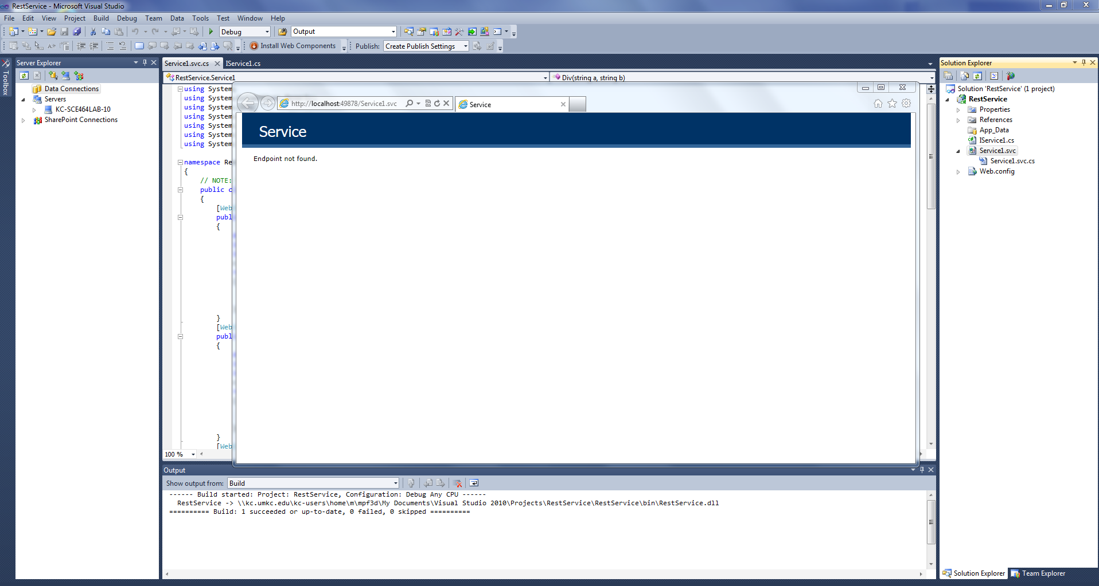

For addition- add2/a/b where a and b are integers.

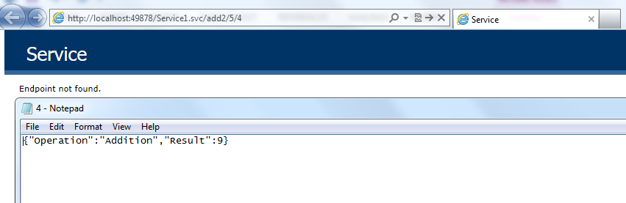

For subtraction- sub2/a/b where a and b are integers.

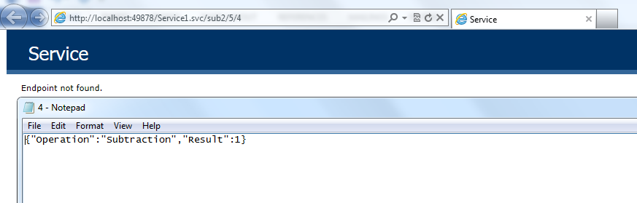

For multiplication- mul2/a/b where a and b are integers.

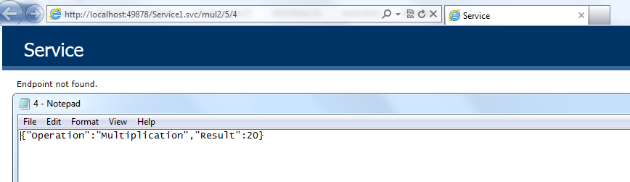

For Division- div2/a/b where a and b are integers.

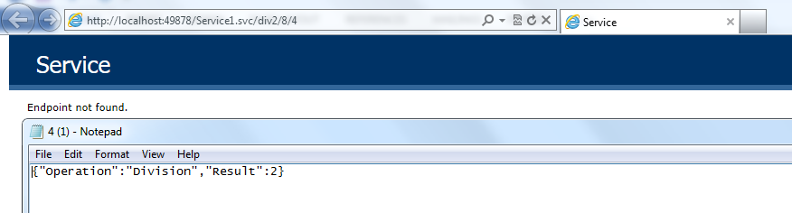

**SOAP SERVICE:**

Here I have developed “MyDetails” link. It will show details of mine. Screen shots are provided below.

Browser View:

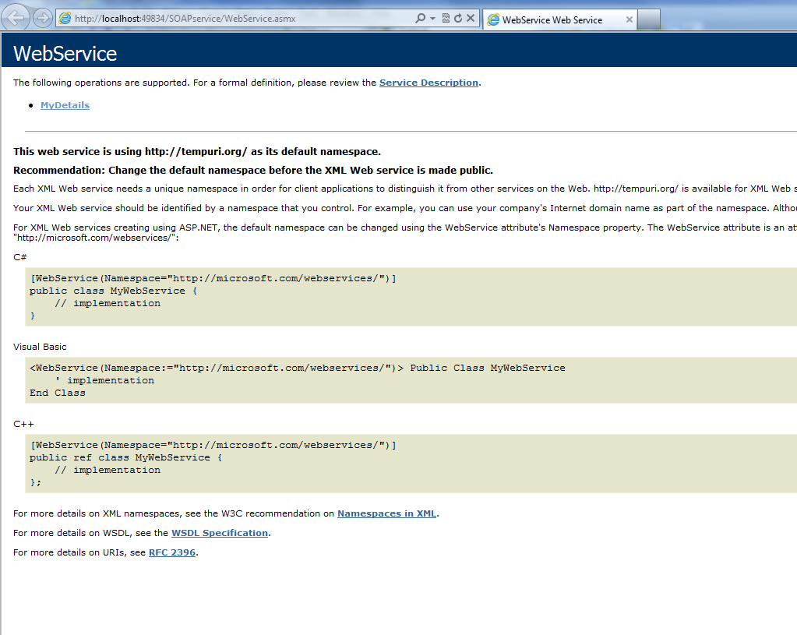

View When I click On MyDetails :

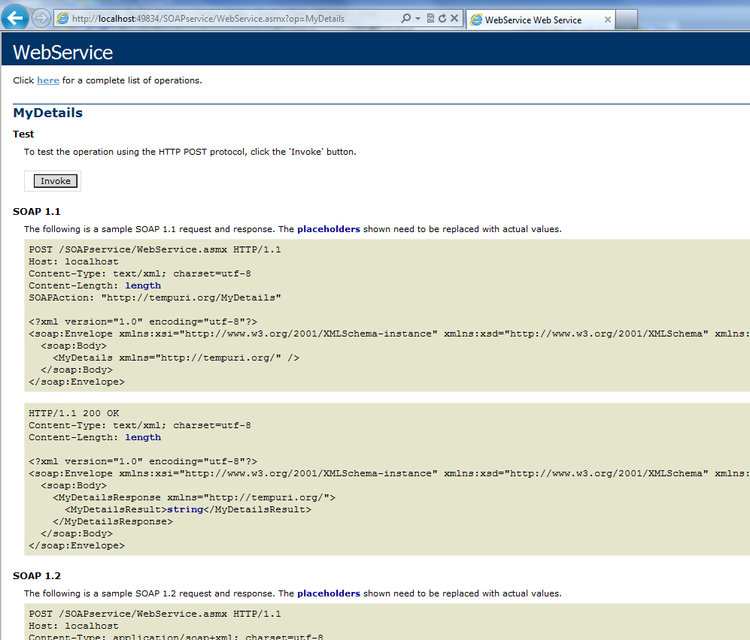

View when I click on INVOKE:

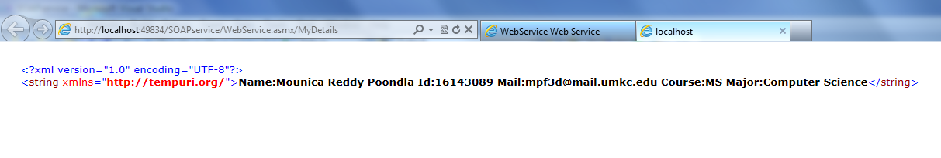

1. **Implement your web services to retrieve, update, delete data from your own database.**

I have created a database in which we can insert data, delete data and retrieve data. We can enter name, age, company name and position. Screen shots are provided below.

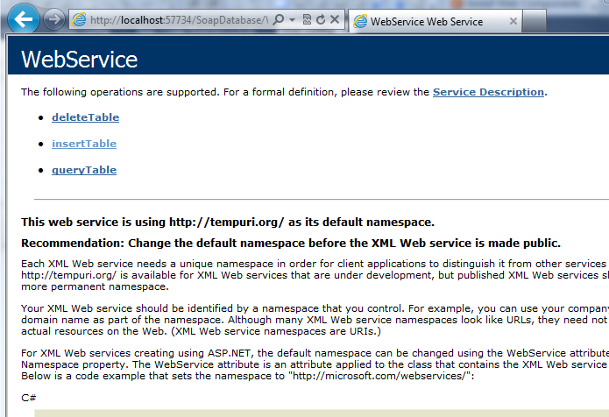

**Insert Data:**

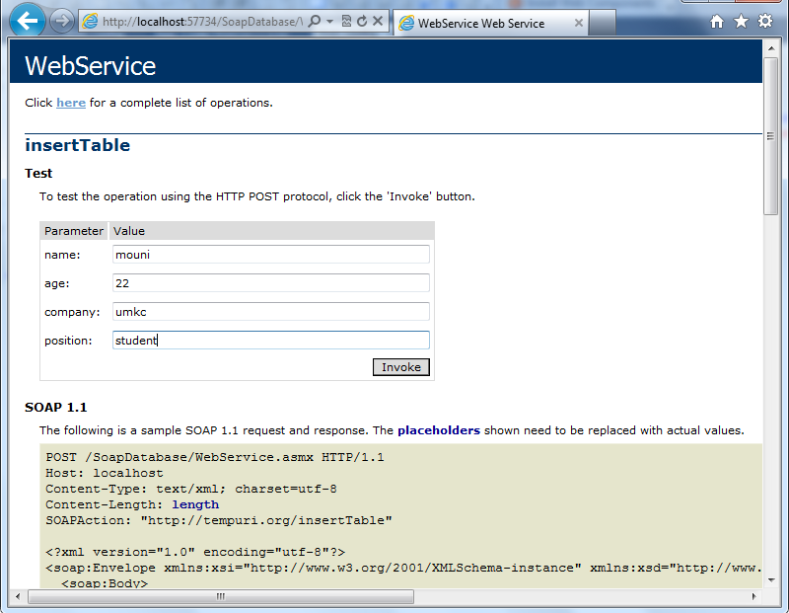

**Retrieve Data:**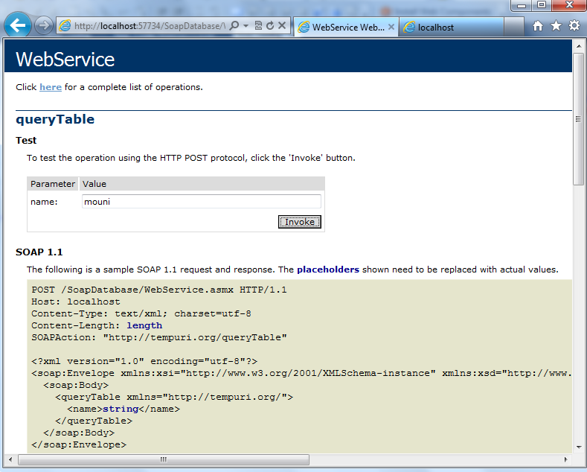

**Delete Data:**

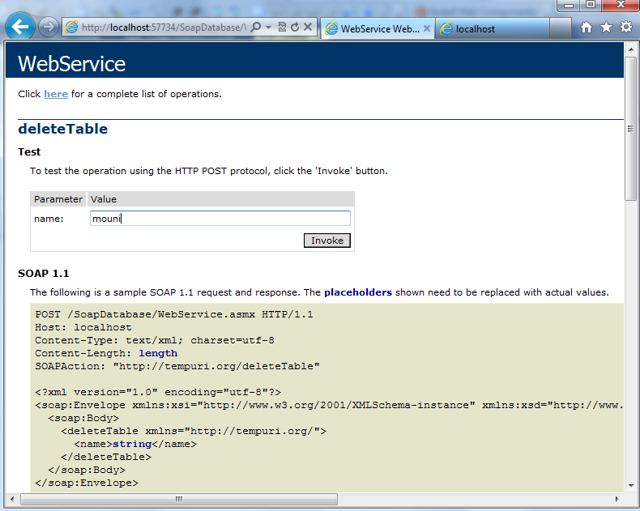

1. **Implement your own mobile client application using your own web services and other web services. The Android app with Web View is recommended for the mobile app development.**

I have implemented my soap service in ADT eclipse. But I could not get the result. Here is the screen shot of it.

